SAMPLE PAPER FOR GRADE 7 CAMBRIDGE (IGCSE)

Q 1.) Simplify the expressions:
- 3(2j – k) – 4(j-2k)
- 4m +5(2n +3p)-4(n-m-p)
Q 2.) Simplify the following:
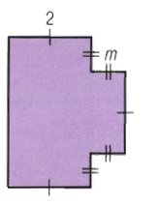
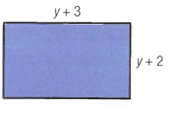
Q3.) How much water is left in 1.5 lit bottle after 750 ml is drunk?
Q4.) The masses of four containers loaded on a ship are 28 tones, 45 tones and 16.8 tones and 48500kg. What is the total mass in tones?
Q5.) How much liquid is in measuring cylinder?
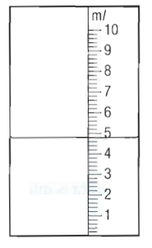
Q6.) The numbers of liters of milk consumed in a group of 150 houses are shown in the table:
Number of liters | 1 | 2 | 3 | 4 | 5 | 6
frequency | 27 | 54 | 34 | 16 | 15 | 4

Show this information on frequency diagram.
Q7.) A family of four people check in their suitcases at the airport. The weight of four suitcases are 18.5 kg, 26.2 Kg, 15.4 Kg and 23.7 Kg.
- Calculate the total weight of the four cases.
- The weight limit for four cases is 100 Kg.
Calculate how much extra weight the family would have carried.
Q8.) a. Draw a triangle with one line of symmetry.
draw a regular hexagon and explain how many lines of symmetry it has with order of rotational symmetry.
Q9.) A plane is flying at 8200 m above the sea. It drops a sonar beacon to ocean floor. The beacons fall 9650 m. How deep is the ocean at this point?
Q10.) Draw the triangle ABC. After construction measure the side AC and BC and angle C.
AB = 7cm Angle A = 50 degrees Angle B = 40 degrees

