WORKSHEET ON LINEAR EQUATIONS GRADE 8 (IB)
- Solve

- 3x + 13 = 2(x + 9)

- 3(2x – 1) – 2(x – 4) = 19

- Solve

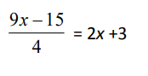
3.Solve
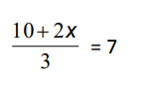
4.
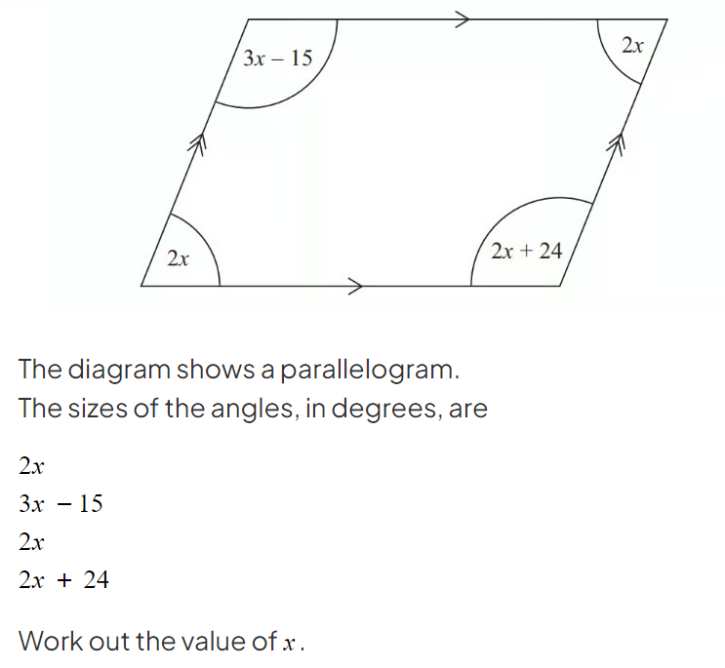
5. Twice the sum of two numbers is 36. If one of the numbers is 10, find the other number.
6. A number consists of two digits whose sum is 12. If 18 is added to the number, the digits are reversed. Find the number.
7. Lauren goes shopping and has £50 to spend. She bought a T-shirt and 3 pairs of leggings. The T-shirt cost £23. Each pair of leggings cost £x
(a) Form an inequality in terms of x.
(b) Solve the inequality to find the possible price of the leggings.
8. Y is a prime number and satisfies
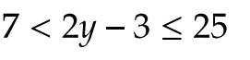
List the possible values of y.
9.
10. 